St George’s School,
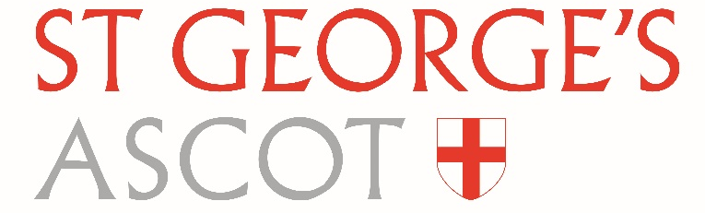
Ascot, Berkshire, SL5 7DZ
Tel: 01344 629900
Fax: 01344 629901
office@stgeorges-ascot.org.uk
www.stgeorges-ascot.org.uk

CONFIDENTIAL: APPLICATION COVERSHEET

Please note this coversheet is NOT referred to when selecting candidates for interview, but includes details which must be made available in order that St George’s School complies with its Safer Recruitment in Education obligations.

St George’s School is an equal opportunities employer and under the Equality Act 2010 and to ensure that our positions attract a diverse range of people, applicants are asked to give additional details about themselves, which are possible sources of unfair/or unlawful discrimination in selecting people for jobs. These details will assist St George’s School, Ascot in operating its equal opportunities policy.

Position Applied for:
Title
Surname
Forename(s):
Date of Birth*
Please provide details of any adjustments/ special requirements to assist you should you be shortlisted for interview:

Do you need a UK work permit to do this job under the terms of the Immigration and Asylum Act 1996? | YES /NO  Please give details of any permit currently held:

What is your ethnic origin? | White Black (African) Black (Caribbean)  Black (Other) Asian Chinese  Other

* necessary in order to comply with St George’s School Safer Recruitment Policy.

